Design Documentation

Summary: Care for a pet, by feeding, giving it water and attention, thus making the pet more attached to you. By caring for the pet, the player becomes more attached too. The game will be for mobile devices and free to play.

The pet will have the following traits as a base:

* Happiness (how happy the pet is)
* Love (how attached the character is to the player)
* Hunger (how hungry the pet is)
* Thirst (how thirsty the pet is)

The traits are influenced in the following ways:

* Love mainly increases from player interaction, e.g. petting the character, but also from high levels in the other categories
* When hunger increases, thirst decreases slightly
* When hunger and thirst increase, so does happiness slightly. When hunger and thirst decrease, so does happiness slightly.
* When happiness decreases so does love slightly.
* All attributes decrease slightly over time.

We are aiming to give the player the “plate spinning” type of gameplay, as shown in the Core loop:

Rewards:

* Major reward is the pet becoming more attached to the player (deepening the bond)
* Rewards are also tied to the way of collecting resources (To Be Decided)

Other potential gameplay elements:

* Random events can trigger offering the player a variety of options (3-5 options), where each option can lead to a new set of options (following a mini story) or can either give the player resources (food or water) or a positive/negative impact to the traits (gets hungrier or less thirsty). This is similar to the dilemmas presented in This Is The Police, where they trigger on some crimes but not all the time. This gives the player a choice to make, with each one feeling meaningful as something will happen with each choice.

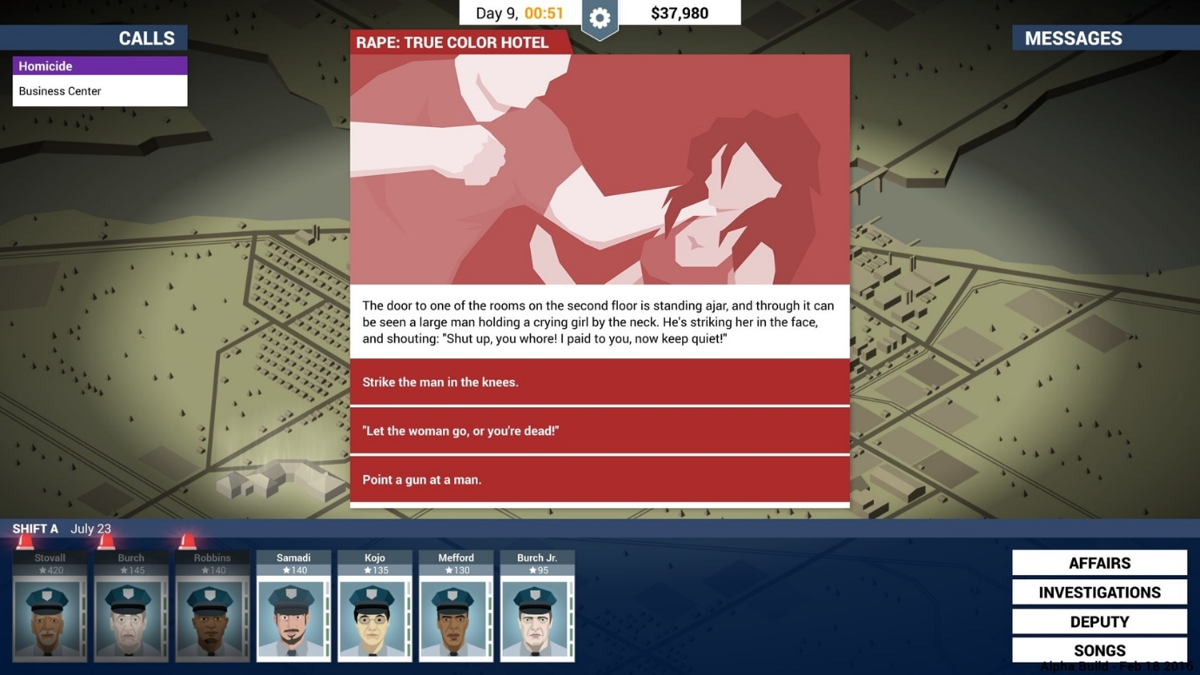

Some helpful info on implementation can be found here:

<https://answers.unrealengine.com/questions/203319/blueprint-pop-up-info-box.html>

<https://forums.unrealengine.com/development-discussion/blueprint-visual-scripting/28351-question-on-how-to-create-info-box-pop-up>

<https://answers.unrealengine.com/questions/225046/how-to-create-a-confirm-dialog-message.html>

* Another way to collect resources could be on a random drop, for example after a certain amount of time or a bar gets to a certain level, a resource could spawn that’s picked up by the left mouse click, which then gets stored in an inventory system.

Useful info on implementation can be found here:

<https://docs.unrealengine.com/latest/INT/Engine/Blueprints/UserGuide/FlowControl/>

<https://wiki.unrealengine.com/Blueprint_Inventory>

<http://www.tomlooman.com/tutorial-basic-inventory-system-in-blueprint/>

* If we want to include a mini game as a way to gain resources, a simple platformer could work, with the player taking control of the pet over a short level, thus gaining resources by collecting them here.

In terms of implementation, the resource variables would need to be tied to the character blueprint, so they can transfer between levels.

Extra help can be found here:

<https://answers.unrealengine.com/questions/36425/how-to-have-character-move-between-levels.html>

<https://answers.unrealengine.com/questions/99904/communicate-between-levels.html>

<https://answers.unrealengine.com/questions/707308/transfering-attached-actors-between-levels.html>